

**ALGORITHM DESIGN AND ANALYSIS**

**TCP2101**

**ASSIGNMENT REPORT**

**TRIMESTER 2 SESSION 2018/2019**

QUESTION 1

Search by Binary Search (AVL tree)

Vs

Search by Hash Search (Hash Table)

PREPARED BY:

|  |  |
| --- | --- |
| STUDENT ID | STUDENT NAME |
| 1161101912 | NG CHAN HAN NICHOLAS |
|  | YU LI BANG |

TABLE OF CONTENT

1. Show dataset of 50,000 URLs
2. Binary searching time in AVL tree
3. Hash searching time in Hash Table
4. Normal Hash Table vs Prime Number Hash Table
5. 0.5 load factors in hashing vs 0.9 load factors in hashing
6. Binary searching time in AVL tree vs Hash searching time in Hash Table

Show dataset of 50,000 URLs

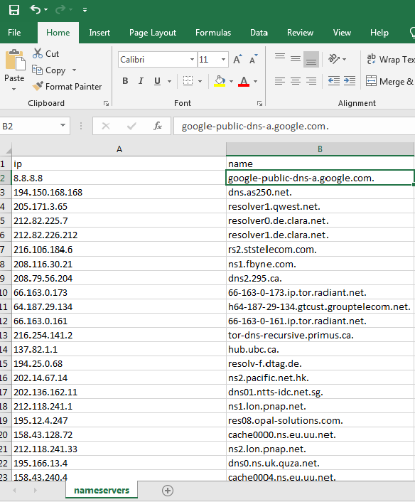

Figure 1: URLs dataset

We get the nameservers.csv file which contain 216670 numbers of unique IP addresses with their unique domain names from <https://public-dns.info/>. We are just using 50,000 of them as testing model in our program. Our task is to let user to search the domain name and the program will return its IP addresses to the user using binary search (AVL tree) and hash search (hash table). Finally, compare the searching time of both algorithms.

Binary searching time in AVL tree

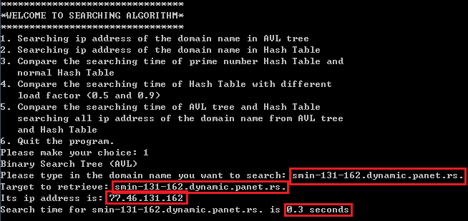

Figure 2.1 Binary searching time

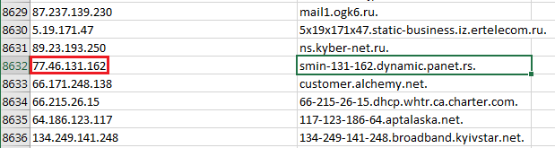

Figure 2.2 The Domain Name selected and return its IP address correctly

Both figures above proven that the IP address returned correctly after searching its domain name. Then the time taken for searching the

domain name: **smin-131-162.dynamic.panet.rs.** is 0.3 seconds.

The searching time (0.3 seconds) is the result of exact searching time which times 100.

The purpose of doing this is to make the searching time clearer and make more sense, since the exact searching time is very small which approximate near to 0.

**Note: All the searching time mentioned below is the result of exact searching time which times 100.**

Hash searching time in Hash Table

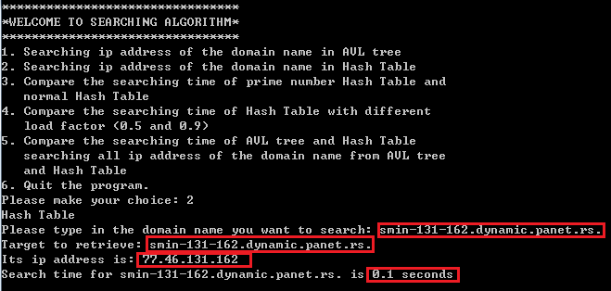

Figure 3.1 Hash searching time



Figure 3.2 The Domain Name selected and return its IP address correctly

Both figures above proven that the IP address returned correctly after searching its domain name. Then the time taken for searching the

domain name: **smin-131-162.dynamic.panet.rs.** is 0.1 seconds.

The searching time (0.1 seconds) is the result of exact searching time which times 100.

The purpose of doing this is to make the searching time clearer and make more sense, since the exact searching time is very small which approximate near to 0.

Normal Hash Table vs Prime Number Hash Table

|  |  |
| --- | --- |
|  |  |
| Figure 4.1 This is the function implementation for setting up the size of the hash table | Figure 4.2 One of the hash table size using even number (8) and the other one using prime number (7) |



Figure 4.3 The searching time results

The both results are taking the 50,000 set of URLs testing model, so the results not suit to what we expect which, Prime Number Hash Table searching time should be lesser than Normal Hash Table searching time.

Note: If reduce the testing model number from 50,000 to 10,000, then we will get the result what we expected.

0.5 load factors in hashing vs 0.9 load factors in hashing

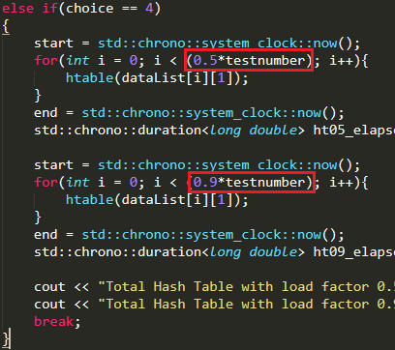

Figure 5.1 The load factors of 0.5 and 0.9



Figure 5.2 The searching time results

The both results are taking the 50,000 set of URLs testing model, the results are what we expected which a lower load factor hashing, the searching time will be lesser than a higher load factor hashing.

Binary searching time in AVL tree vs Hash searching time in Hash Table

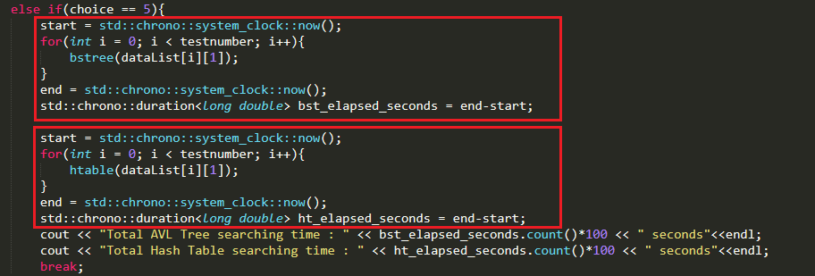

Figure 6.1 Compare both algorithm total running time



Figure 6.2 The searching time results

Based on Figure 6.2, we can conclude the theory which hash searching is faster than binary search.

Conclusion

Based on the experiment above, we can say that Hash searching in Hash Table is faster than Binary searching in AVL tree.

